Experiment No. 1
FLASHING OF LED USING AT89C51 MICROCONTROLLER USING PROTEUS
Objectives
- To study the basic operation of AT89C51 microcontroller.
- To interface an LED with microcontroller.
- To generate LED blinking using a software delay.
Program:
ORG 0000H
UP: SETB P2.0
ACALL DELAY
CLR P2.0
ACALL DELAY
SJMP UP
DELAY: MOV R4,#35
H1:MOV R3,#255
H2:DJNZ R3,H2
DJNZ R4,H1
RET
END

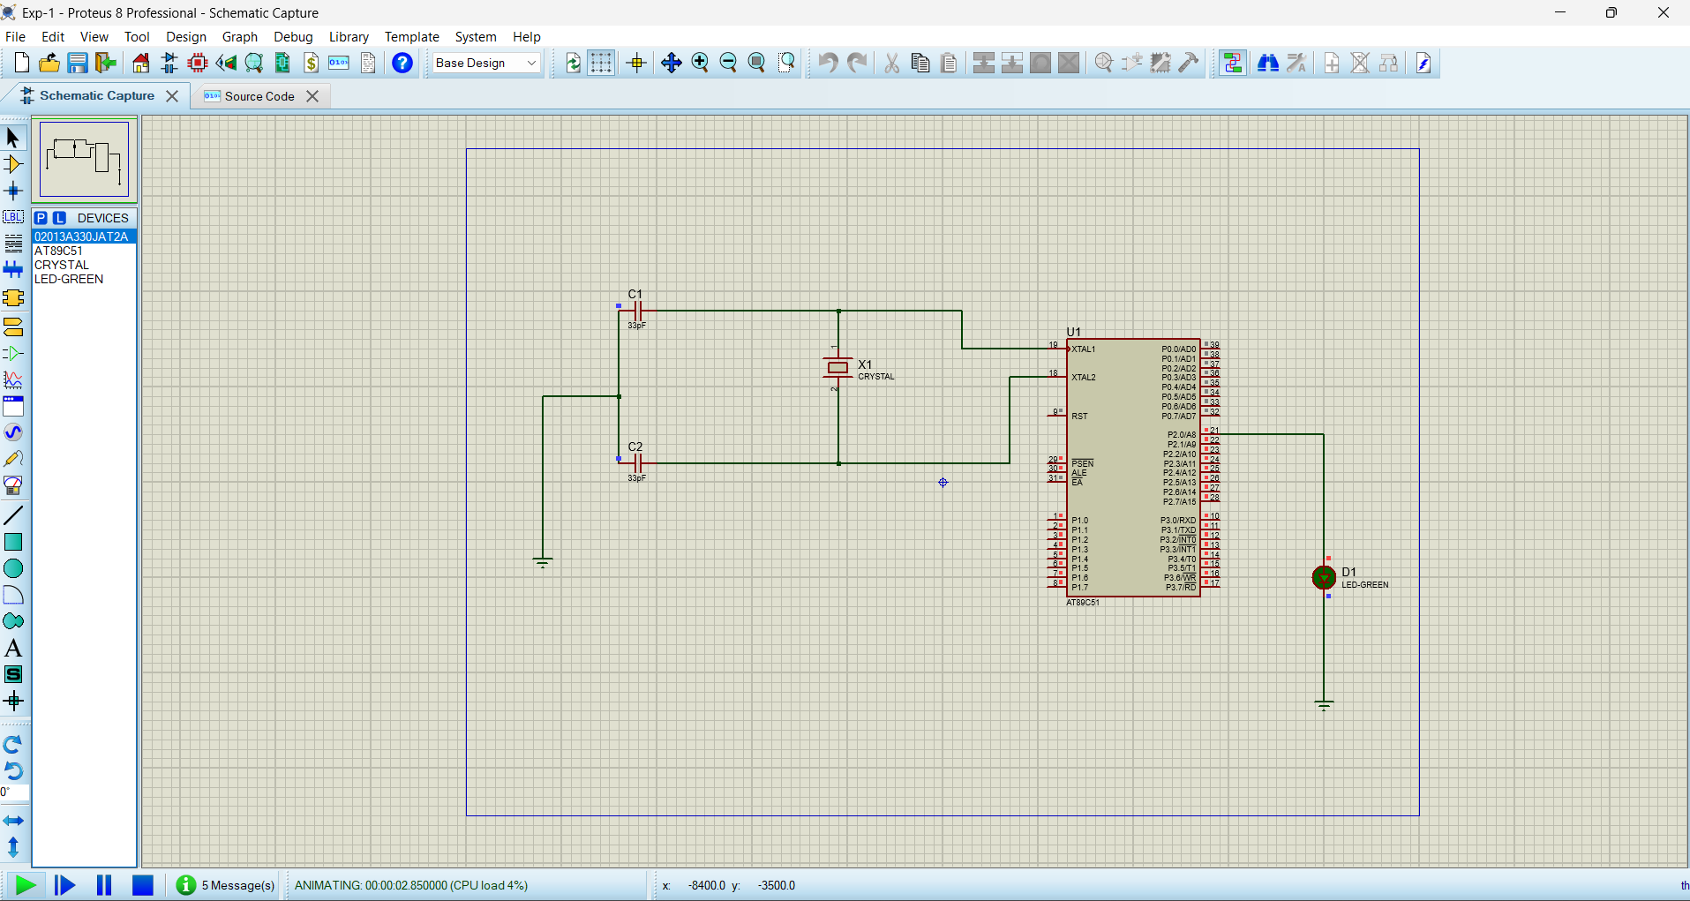
Output:

